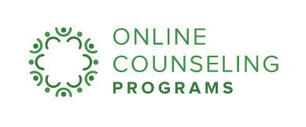
According to the National Alliance on Mental Illness (NAMI)¹, 1 in 5 Americans suffer from mental health concerns. However, 49 states² experience a shortage of licensed professionals who can help.

Are you a U.S. citizen and an aspiring mental health counselor? You could qualify for student loan repayment assistance simply by obtaining your graduate degree, becoming a licensed professional counselor or marriage and family therapist, and committing a couple of years to working in a Health Professional Shortage Area (HPSA)³ within the 21 different states outlined in an infographic, including Louisiana found here.

Louisiana offers loan relief in the form of tax-free funds that are administered by the U.S. Department of Health & Human Services and the Health Resources & Services Administration (HRSA)⁴, however, some states are provided additional federal funding through the State Loan Repayment Program (SLRP)⁵.

By looking at the infographic, you can chart how Louisiana compares in award amount as well as the percentage of mental health needs that are currently being met by licensed professionals.

- With a minimum of a 2 year commitment of employment at an approved site, state and federal funding is offered to repay student educational loans for licensed professional counselors and marriage and family therapists.
- These eligible sites range from free clinics to hospitals and prisons.
- Additional requirements and service obligations are state specific and explained in comprehensive guidelines that are accessible online.

Through loan repayment programs, you can make an impact for communities in need without the weight of student debt. For further application details and eligibility requirements, be sure to visit the National Health Services Corps website.

Resources:
¹http://www.nami.org/NAMI/media/NAMI-Media/Infographics/GeneralMHFacts.pdf
²http://kff.org/other/state-indicator/mental-health-care-health-professional-shortage-areas-hpsas/?currentTimeframe=0
³http://bhw.hrsa.gov/shortage-designation/hpsas
⁴https://www.hrsa.gov/index.html
⁵https://nhsc.hrsa.gov/loanrepayment/stateloanrepaymentprogram/

